Department of Computer Science

CS220: Advance Database Management Systems
Class: BSCS-13E

Lab 1: MySQL and Workbench Environment and Basic SQL Revision

Date: January 30, 2025

Time: 10:00-1:00

Instructor: Dr. Rabia Irfan

Lab Engineer: Syed Muhammad Ali Musa

Muhammad Faseeh
BSCS 13-E
456267

Lab 1: MySQL and Workbench Environment

Introduction

Data is a collection of raw facts and figures. It is being processed to obtain useful information to assist organization in taking better decisions. Database is an organized collection of related data. In order to manage the databases, Database Management Systems (DBMS) or Database Systems offer sets of program and tools to efficiently access and manage the databases.
Relational data model is used to model the databases in Database Systems in the form of relation (table) comprising of tuples (rows) and attributes (columns). Primary key is the unique identifier for the relation and foreign key is used for referential purposes by the relation to include or refer to other relations data.
Structured Query Language (SQL) is used to access and modify the relational database. It is the most widely used query language supported by modern database management systems. SQL is a nonprocedural language.

Objectives

After performing this lab the students should be
  - familiarized with MySQL and Workbench environment
  - Load or unload a database in MySQL through MySQL Workbench
  - Explore structure of tables in a database
  - Create a test database and tables

Tools/Software Requirement
Tools | Purpose
MySQL Community Server (5.6+) | Freely downloadable version of the world's most popular open source database
MySQL Workbench (8) | MySQL Workbench provides a graphical tool for working with MySQL Servers and databases

Description
Understanding the Work Bench Environment

MySQL Workbench is a unified visual tool for database architects, developers, and DBAs. You can find it installed on your workstation. Select Start>Program>MySQL>Workbench to start up. The home screen shown in Figure 1:

Figure 1: Workbench Home Window

2. When MySQL Workbench first starts, it presents the Home window, which has three main sections:

- List of MySQL Connections (help to manage and connect with MySQL server that actually runs the database)
- Models (facilitate database design)
- Shortcuts (quick access)

3. MySQL Workbench provides extensive facilities for working directly with SQL code. Before working directly with a live server, a connection must be created using MySQL Connections section on Home Window. After a connection is established, it is possible to execute SQL code directly on the server and manipulate the server using SQL code.

Making connection with MySQL Server

1. To administer your MySQL Server, you must first create a MySQL connection. Creating a MySQL connection is often the first action performed after installing MySQL Workbench.

2. To add a connection, click the [+] icon to the right of the MySQL Connections label on Home Window. This opens the Setup New Connection form. Fill out the connection detail as shown in Figure 2:

Figure 2: MySQL Server Connection Setup Window

3. Define the Connection Name value as MyFirstConnection. Click OK. The connection will appear in MySQL Connections list on Home Window.

4. Select the MyFirstConnection from Home Window, this opens the SQL Editor screen as shown in Figure 3:

Figure 3: SQL Editor

5. For querying use SQL Query menu. It will open the SQL Query Panel as shown in Figure 4:

Figure 4: SQL Query Panel

Using the Sakila database

1. Download and unzip Sakila database. The archive contains three files: sakila-data.sql, sakila-schema.sql, and sakila.mwb.

2. Now right click and select drop on an existing database schema named Sakila. You will load it a fresh.

3. From File menu select Open SQL Script. Select sakila-schema.sql from the file selection dialog. It would open the file in the query pan. Now select Execute All from Query menu. You can alternatively press the Execute All icon from the toolbar. Don’t forget to check the log pan below the query tab. It mentions all errors, warnings, and messages.

4. Press the refresh icon in the schema section . You must see Sakila database in the list of the databases.

5. Repeat the process for sakila-data.sql file. If all goes well, you have successfully loaded the sakila database and now you can close the files (but not the Workbench).

6. Expand the Sakila database. Among the listed categories, expand Tables. You will see list of tables (relations) in Sakila database

7. Right click on a table and explore the second option Table Inspector. It opens a new tab showing relation schema, attribute names and other metadata.

8. Afterwards right click on the same table and explore the first option: Select Rows. It will open another tab for navigating through the contents of the relation.

9. The data view supports many different options such as sorting on a column by selecting its header, searching contents, deleting a row, adding another, or exporting the contents to an external file. You can play with these options.

Examples:

SQL is a structure query language which is not a full featured programming language; it is only a data sublanguage, which has commands for data definition and processing. Data definition commands are Data Definition Language while data processing commands are Data Modification Language. In first lab we will focus on DML commands for which we will use Sakila Schema which we have already downloaded and is a sample data base. With the passage of time we will be able to design our own database.
When we are working on any schema, we need to set that schema as default.

Right click on sakila and select first option,“set as default schema” from menu.as shown below.

Figure 5: Setting Default Schema

Expand “Sakila”, there are further tabs as tables,views etc.Expand “Tables”.

You will find various tables including actor, class, catogory etc. All these tables have data stored. You can retrieve or update data using SQL commands.

Explore various tables of the sakila database and columns that are present in a particular table. Observe how data is stored in a table.

Retrieving Data from Tables:

When you want to retrieve some data from a table, Select statement will be most commonly used statement.
Syntax of Select statement is

Select Column name From Table name;

You can select multiple columns separated with commas or single column.

Selecting all the columns
Select * from Customers;
Selecting specific columns
Select customer name, customer id from Customers;
Example 1:
Write a query in query 1 tab.

Select actor_id from actor;

It will select actor Id column from actor table which is present in sakila database and show you the results.

SQL Basic Query Structure

The SELECT clause
The most common use of the SQL commands is the selection of data from the tables located in a database. This can be achieved through SELECT command. We need to SELECT information FROM a table. Hence we have the most basic SQL query structure comprising of:
- SELECT
- FROM
- WHERE
The syntax for SELECT clause is as follows:

SELECT "column_name(s)" FROM "table_name(s)";

Always specify the name of the database in which a table/relation is present through which data is to be retrieved.

e.g. Select column_name
From Sakila.table_name

There are three ways we can retrieve data from a table:
- Retrieve one column
- Retrieve multiple columns
- Retrieve all columns (Use *)

The select clause can contain arithmetic expressions involving the operation, +, –, *, and /, and operating on constants or attributes of records (tuples).

The FROM clause
The FROM clause can allow to select attributes from single table or multiple tables. When multiple tables are applied, it combines the records from the two or more tables listed and presents every possible combination of the listed attributes in SELECT clause.
This is not very useful until some filtering condition is applied. This is achieved through using the WHERE clause.

The WHERE clause
We can use the WHERE clause to filter the result set based on certain conditions. The syntax for using WHERE in the SELECT statement is as follows:
SELECT "column_name(s)"
FROM "table_name(s)"
WHERE "condition";

"Condition" can include a single comparison clause (called simple condition) or multiple comparison clauses combined together using AND or OR operators (compound condition). Conditions can include other operators like IN, BETWEEN, DISTINCT etc shown in Table 1:
Operator | Description | Example
= | Equal to | Author = 'Alcott'
<> | Not equal to (most DBMS also accept != instead of <>) | Dept <> 'Sales'
> | Greater than | Hire_Date > '2012-01-31'
< | Less than | Bonus < 50000.00
>= | Greater than or equal | Dependants >= 2
<= | Less than or equal | Rate <= 0.05
BETWEEN | Between an inclusive range | Cost BETWEEN 100.00 AND 500.00
LIKE | Match a character pattern | First_Name LIKE 'Will%'
Table 1: List of Basic Operators available in SQL
Examples:

select* from country

where country='Pakistan'

select title from film
where rental_duration < '6'

Ordering data
The order of rows returned in a query result is undefined. The ORDER BY clause can be used to sort the rows. This clause comes last in the SELECT statement. ASC at the end of the ORDER BY clause specifies ascending order where as DESC specifies descending order. ASC is the default order. The syntax for an ORDER BY statement is as follows:
SELECT "column_name"
FROM "table_name"
[WHERE "condition"]
ORDER BY "column_name" [ASC, DESC];

select title from film

where rental_duration < '6'

order by title DESC

Lab Tasks
- Write a query to Select columns “city_id” and “country_id” from the table “city” which already exists in the “Sakila” database. (Observe the output when you execute the queries.)
select country_id, city_id from city;
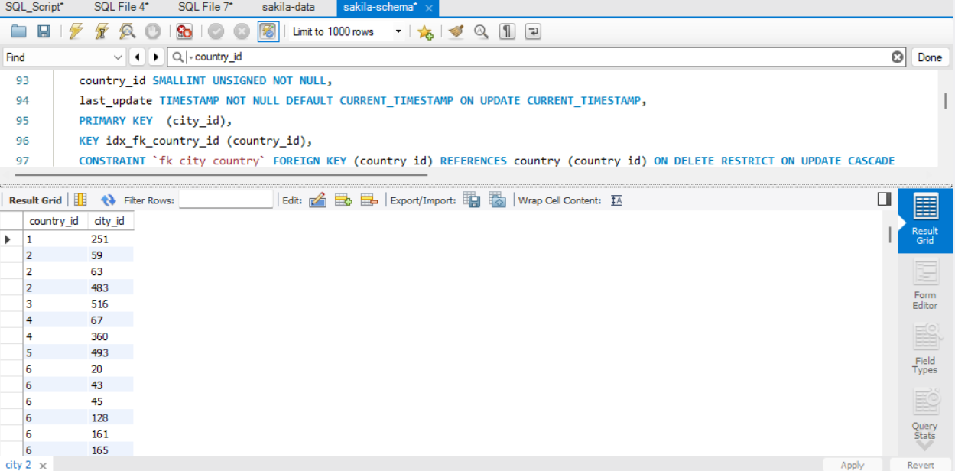
- Write a query to retrieve first and last name of actors.
select first_name ,last_name from actor;
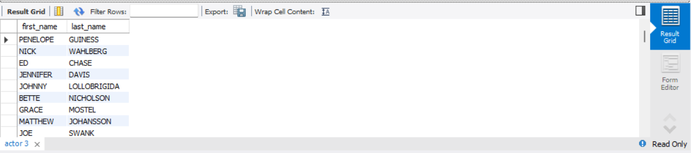
- Write a query to Select column “actor_id” from the table “actor” which already exists in the “Sakila” database where the “actor_id=58”. (Observe the output when you execute the queries.)
select actor_id from actor where actor_id="58";
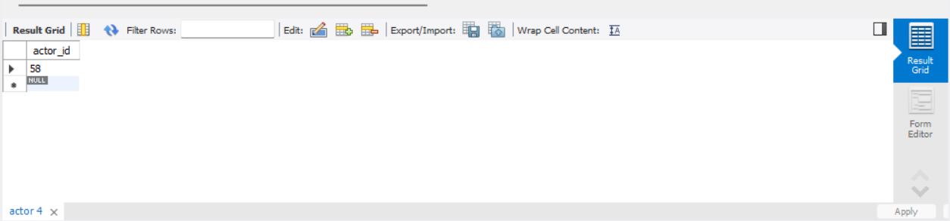
This one is with First and last name for a more detailed view:
select first_name,last_name,actor_id from actor where actor_id="58";
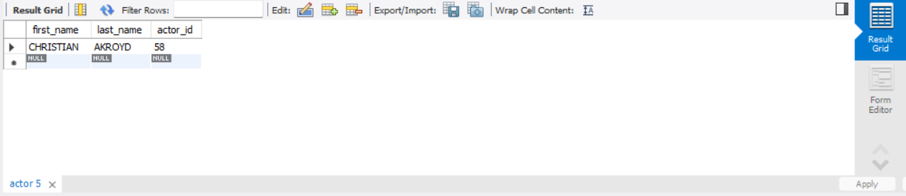

- Write a query to retrieve names of movies starting with P display movies names in desc order.
select title from film where title like 'p%' order by title desc;
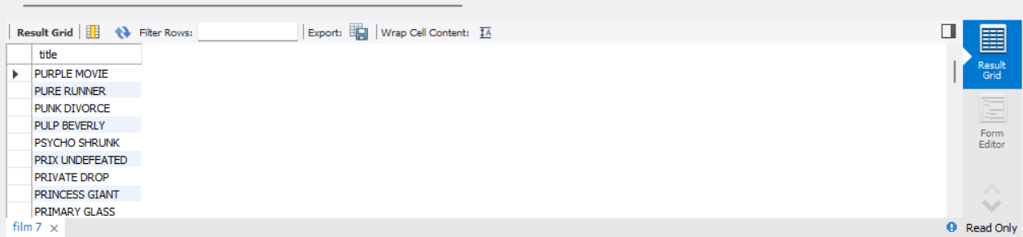

- Write a query to retrieve movies which were released in year 2006
select title from film where release_year="2006"
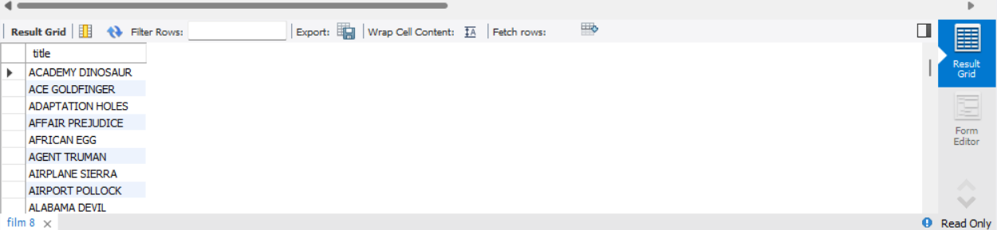
select * from film where release_year="2006"
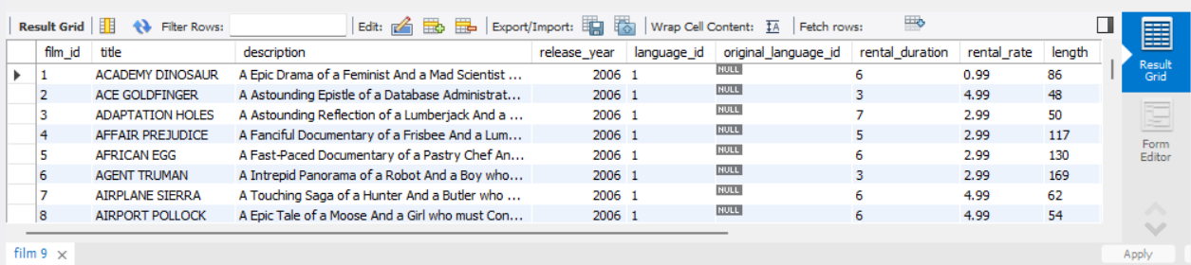
Both queries are almost same. The only difference is that in 1st I’m selecting title only, while the other iI’m selecting everything.
Deliverables
Complete your labs tasks and write queries and the steps/screenshots of all the questions attempted in a document and upload on LMS. The marking will be based on viva/lab task submitted or the quiz that takes place at the end of the lab.

